Student Management System

**26-12-2016**

Muhammad Saad

Mehran University Jamshoro

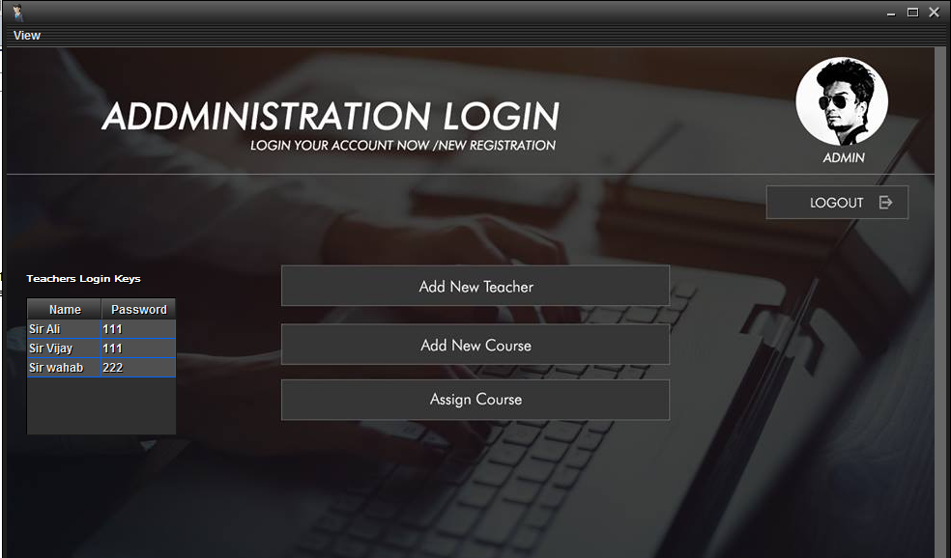

Student Management System

In this project there are two vital role

1. Admin
2. Teacher

Admin:

Default Username : saad

Default Password : saad

Admin have authority to Add ,Delete and Update a teacher , course

Admin have also to assign any course to teacher (Resistriction :One teacher contain only on course )

Admin can check all the record of teacher and his students (go in View -> All records)

Teacher :-

Default Username : sir ali

Default Password : 111

Teacher have authority to add .delete or update their students

Teacher have also authority to submit the fee of his students

This is my Final Project I hope you will like this .

Thanks Regards ☺

Asalam-O- Aliqum

Introduction

My name is Saad and I am from Mehran university in Software Engineering department

I am currently completed the of core Java course from Gexton Education